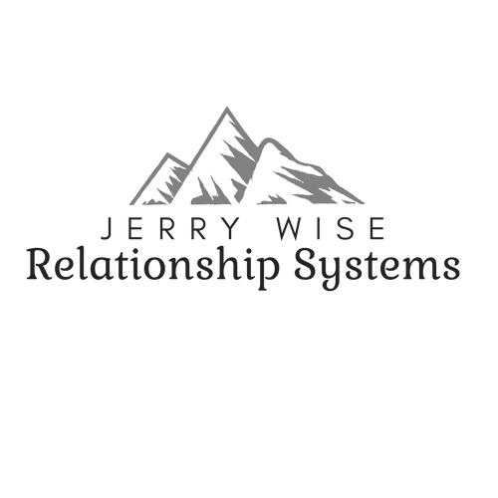  New Website:  https://www.jerrywiserelationshipsystems.com/  Jerry T. Wise, MA, MS, CLC Relationship Systems & Self Differentiation Expert Jerry T. Wise, MA, MS, CLC Jerry Wise Relationship Systems 317-919-6264 jerrywise5@gmail.com | Facebook:  Jerry Wise Relationship Systems  Twitter:  @jerrywisers  YouTube:  Jerry Wise Relationship Systems  Vimeo:  https://vimeo.com/ondemand/jerrywise  I will be providing 2-hour workshops on Zoom.us soon. Look for information coming your way on being participant for a live workshop/seminar by Jerry Wise, MA, MS, CLC  After the workshop is over each workshop will be posted on Vimeo OnDemand Jerry Wise web page for pay-per-view watching.

Hi,

Thanks for writing to me.

Thanks for watching my videos and don’t forget to subscribe!

Here is some information about me and my services.

My FEE is $350.00 (U.S.)/ coaching hour for individual, couple, and family work
(Clients have found that clients get more done and more quickly with fewer sessions with me than working with less experienced coaches and therapists.)

Please contact us text at 317-919-6264 or jerrywise5@gmail.com or by phone call. I do not check Facebook inbox or Google Hangouts that often.
- A complete listing of all my free videos on YouTube
- Information about working with me online, in the office, via skype or facetime, fees, etc.
- Resources for learning about Self-Differentiation and recovery
- Resources for ACOA/ACA Adult Children of Alcoholics recovery
- Resources for Adult Children of Narcissistic Parents
Please let me know if you have any questions.

Let me know how I can be of help, or if you would like to schedule an appointment/session.

Thanks again for contacting me.

Sincerely,
Jerry Wise
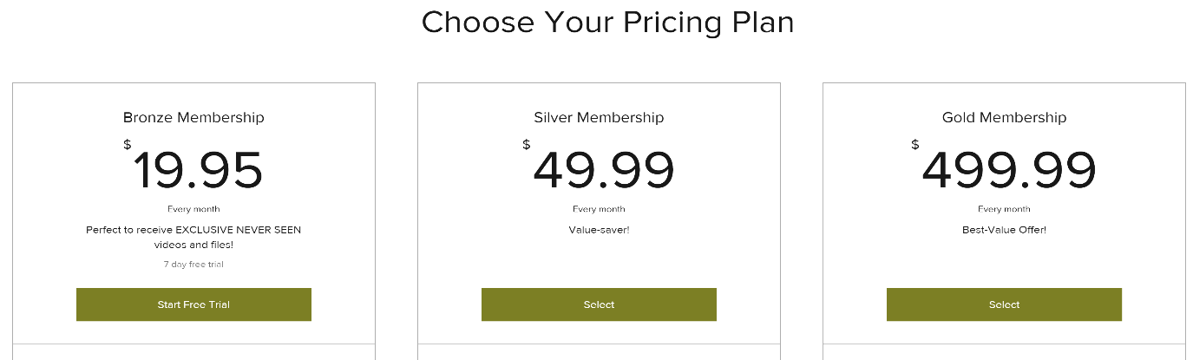
Bronze ($19.95)-
Which includes:
Exclusive Content (Videos- every week)
Full Access to Notes and Files from Jerry Wise (every week)
Silver ($49.99)-
Which includes:
Exclusive Content (Videos-every week)
Additional Files and Workshops
An 1-hour Group Session (Every Month)
Discounts to Schedule 1-on-1 Sessions
Gold ($499.99)-
Which includes:
All Included Exclusive Content (Files, Videos, Workshops)
One-free Entry to Future Workshop
Personalized Video (Of Your Choice, Once a Month)
1-hour Group Session (Once a week, 45 mins.)(On Zoom)
Free Personalized Mug
Discounts on Merchandise and 1-on 1 Sessions
ONE FREE SESSION (50 mins.)
Meet The Team

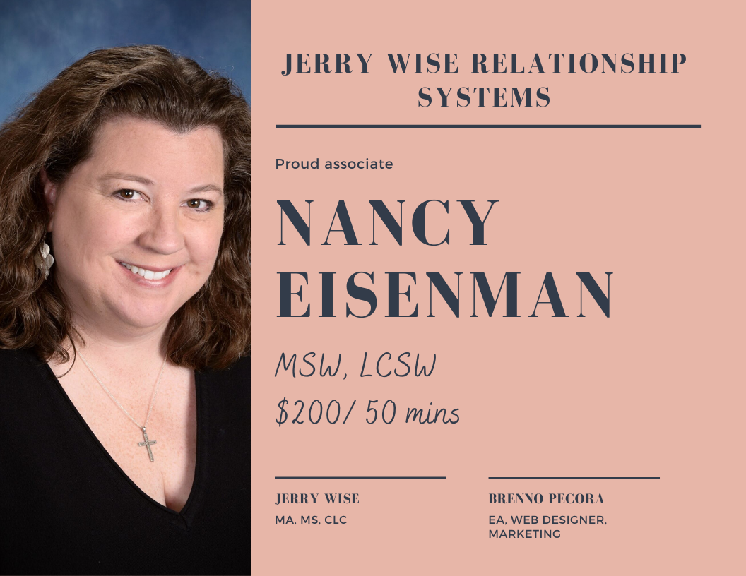
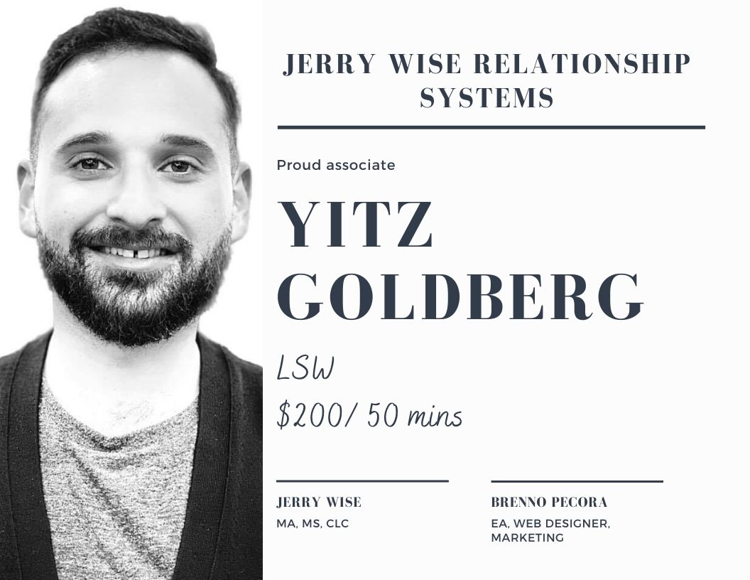
Doing Skype (PC computers), Facetime (Internet
Apple) or Phone Coaching/Consulting
Office of Jerry T. Wise, MA, MS
Director
Center for Self-Differentiation at
Online Coaching and Consulting
Expert Life & Relationship Coaching

1. Skype, Facetime, IMO, Zoom, Google Hangouts, or Phone Coaching or Consulting is an exciting way to connect to a great expert and not be limited only to the counselors or life and relationships coaches in your local area
2. Skype Coaching is personal, confidential, convenient, and affordable. No matter where you live or where you travel you can have professional help via the Internet. I provide concierge help for those who need convenience and help. I also travel to clients and provide personal face-to-face help from intensives (one to three days) with individuals, couples, and families with follow up sessions via the internet.
3. I obtain information from client (e.g. address, email address, phone number and Skype ID, etc.)
4. Payment is easy and quick with a credit card or billing options (credit card, billing, personal check, etc.) Credit card is my preference. PayPal is also an available option.
5. FEES and Length of session: 50 minutes $350.00 (typical session is 50 minute) Fee is $350.00 (US) per 50-minute hour. Payment is due at the time of service, unless we agree to, and discuss, a payment delay.
6. Initial session we discuss the current issues and problems
7. Often, though not always, the initial and second session I obtain do an assessment and ask questions about current problems and genogram (family emotional history)
8. We can meet as frequently as the client desires; there is no set frequency or number of times we have to meet
10. Emails will be answered by Jerry Wise, if the emails are long and require heavily involved responses I reserve the right to charge the hourly fee for reading and responding.
11. I use very good lighting and audio and visual (IPAD) equipment for sessions so you can see and hear me clearly.
12. Appointment Cancellation Policy. It is important that any client give a 24-hour notice for cancellation of any appointment. I have reserved the time you have asked for so no one else can have that appointment. If you fail to give a 24-hour notice I will invoice you (or charge your credit card) for the missed appointment. I understand medical emergencies and personal or family emergencies, but work issues or work conflicts are not a reason for me not to charge the client.
13. Jerry T. Wise, MA, MS has been a marriage and family therapist, addictions therapist, social worker, pastoral counselor, ACOA expert, psychiatric family therapist, codependency expert, pastor, popular workshop speaker, therapist trainer, You Tube video educator, author, and organizational consultant, professional vocalist and musician. He holds degrees in political science, music, psychology, marriage and family therapy. Presently, he now offers online help and professional coaching for individuals and couples. As a self-differentiation coach/consultant/facilitator he uses his knowledge in family systems theory to help clients get un-stuck and find a true sense of self. If someone would like to seek help from a therapist, I will refer them to an appropriate professional.
- Unfortunately, I do not bill insurance companies for my professional services. And starting in January 1st 2019 I will not be available to provide any insurance claims for my services.
- After we schedule and appointment and decide what device we will use (Skype, Facetime, Phone) I will be calling you or initiating the call. If you call me I may still be with a client before you and cannot answer the call. Please give me a 5-10-minute leeway for our appointment to begin. I do try to work to stay on time for clients. If I am 15 minutes late and you have not heard from me then please call me. Typically, if I am going to be late I will contact you before our session via text and let you know.
- I have many international clients (E.g. Europe, Russia, Dubai, Canada, UK, Australia, Egypt,). I can work out times to fit the time differences between us.
- Clients may record the sessions with Jerry Wise for future reference. I do allow clients to do this. I have had many clients who feel taking notes or recording the sessions help them to reflect after our sessions.
- I am sorry I do not do coaching via email. However I will communicate and assist current clients with email responses.
All client information is confidential and will not be shared with anyone without permission of the client.
*Confidentiality: Any coaching relationship with Jerry T. Wise, MA, MS, as well as all information (documented or verbal) that the Client shares with the Coach as part of this relationship, is bound to confidentiality by the ICF Code of Ethics but is not considered a legally confidential relationship (like in Medicine or Law). The Coach agrees not to disclose any information pertaining to the Client without the Client’s written consent. The Coach will not disclose the Client’s name as a reference without the Client’s consent. Confidential information does not include information that: (a) was in the Coach’s possession prior to its being furnished by the Client; (b) is generally known to the public or in the Client’s industry; (c) is obtained by the Coach from a third party, without breach of any obligation to the Client; (d) is independently developed by the Coach without use of or reference to the Client’s confidential information; or (e) that the Coach is required by law to disclose.
DONATIONS for new videos!
If you have enjoyed the FREE VIDEOS of Jerry Wise on You Tube and you would like to see more videos, please donate on PayPal at jwlearning@hotmail.com to support the work of self differentiation and the production of more videos. Any gift will help build the community of those seeking help with self-differentiation.

Go on to my YouTube Channel in where you can browse through my over 160 videos ranging from topics such:

Adult Children of Alcoholics (ACOA)
https://www.youtube.com/watch?v=QMHtkBapBZI&list=PLoYQTW09i3W0O69XKiaiDRQlO6ni5m5Tl

Adult Children of Narcissists
(ACON)
https://www.youtube.com/watch?v=P0A6mQPWfXI&list=PLoYQTW09i3W1P83VpgMeAdJR-iTVnMPIA

Self-Differentiation
https://www.youtube.com/watch?v=cQEZHl4VGqU&list=PLoYQTW09i3W1Pg9Bu9dHLwIPTud37ibwk

Family of Origin Issues
https://www.youtube.com/watch?v=zGwc35OQyF4&list=PLoYQTW09i3W3dZUvQvxFy_bxrH6vBXMrS
These are great resources and article recommended by Jerry Wise

Differentiation of Self or How to Get Your Own Life And Not Get Overwhelmed By Your Family
http://www.interventions.net/BowenTheoryUpdated.pdf

Family Systems and Christianity

http://yourmindfulcompass.com/dr-bowen/bowen-theory/differentiation-of-self-scal/

Bowen’s Family Systems and Christian Family Spirituality
http://bowenfamilysystemsswift.blogspot.com/2013/05/post-1-christ-likeness-and-self.html

Family of Origin Resources and Self-Differentiation Resource Readings

  - The books in red are good ones for clients; the others are often read by professionals. However, I believe anyone can read them all.

- Bregman, O. and White, C.M. (eds) 2011, Bringing Systems Thinking to Life: Expanding the horizons for Bowen family systems theory, New York, London, Taylor & Francis.
- Brown, Brene, Braving the Wilderness: The Quest for True Belonging and the Courage to Stand Alone
- Brown, Jenny, Growing Yourself Up
- Reilly, Winifred M., It Takes One to Tango
- Burkham, R. 2002 The Therapy Triangle: Empowering you with the knowledge to heal. E-book and paper back. Order here.
- Gilbert, R. M. (2006). The Eight Concepts of Bowen Theory. Leading Systems Press (order from her web site)
- Gilbert, R. M. (1999). Connecting with Our Children. New York, John Wiley .
- Gilbert, R. M. (1992). Extraordinary Relationships. New York, John Wiley
- Harrison Victoria. My Family My Self: A Journal of Discovery order at: info@thefsi.com.au
- Lerner, H. (1988). The Dance of Anger. New York, Harper & Row
- Lerner, H. (1990). The Dance of Intimacy. New York, Harper & Row .
- Lerner, H (2005) The Dance of Fear
- Lerner, H. (2003). The Dance of Connection. New York, Harper& Row
- Richardson, R. (1995). Family Ties that Bind: A self help guide to change through family of origin therapy. Self Counsel Press. USA, Canada.
- Schnarch, D. (1997). Passionate Marriage. New York, Norton
- Bowen, M (1978). Family Therapy in Clinical practice. New York: Aronson.
- Kerr M & Bowen, M. (1988). Family Evaluation. New York Norton
- McGoldrick, M. (1995). You Can Go Home Again, New York, Norton.
- Papero, D. (1990). Bowen Family Systems Theory. Needham Heights, Massachusetts. Allyn & Bacon.
- Titelman, P. (Ed.) (2008). Triangles: Bowen Family Systems Theory Perspectives. New York Haworth Clinical Practice Press
- Titelman, P. (Ed.) (2003). Emotional Cutoff. Bowen Family Systems Theory Perspectives. New York Haworth Clinical Practice Press
- Titelman, P. (Ed.) (1988). Clinical Applications of Bowen Family Systems Theory. New York, Haworth Press.
- Titelman, P. (Ed.) (1987). The Therapists Own Family: Toward the differentiation of Self. Northvale, New Jersey, Jason Aronson
- Bregman & White, (2011) Bringing Systems Thinking to Life: Expanding the Horizons for Bowen Family Systems Theory. Routledge Publishers
- Schara, A. (2013). Your Mindful Compass
- Brown, J. (2014) Growing Yourself Up: How to Bring Your Best to All of Life’s Relationships

ACOA Resources

- Adult Children of Alcoholics- Janet Woititz

- **Twelve Steps of Adult Children (ACA Adult Children of Alcoholics World Service Organizations)

- **ACA Fellowship Text—The Big Red Book (see ACA World Service Organization)

*Excellent Resources*

- Recovery: And Adult Guide for Adult Children of Alcoholics - Herbert Gravits

The Complete ACOA Sourcebook: Adult Children of Alcoholics at Home, at Work and in Love- Janet Woititz

After the Tears—Adult Daughters of Alcoholics- Robert Ackerman

Struggle for Intimacy- Janet Woititz

Loving an Adult Child of an Alcoholic Douglas Bay

It Will Never Happen to Me - Claudia Black

Healing the Child Within- Charles Whitfield

Homecoming: Reclaiming and Championing your Inner Child by -John Bradshaw

An Adult Child’s Guide to What’s Normal -by John Friel and Linda Friel

The Complete ACOA Sourcebook: Adult Children of Alcoholics at Home, at Work, and in Love - Janet Geringer Woititz, EdD

Resources for Dealing with Narcissists
Provided by Jerry T. Wise, MA, MS

- **Healing from a Narcissistic Relationship: A Caretaker’s Guide to Recovery, Empowerment, and Transformation by Margalis Fjelstad

- Healing the Adult Children of Narcissists: Essays on the Invisible War Zone
By Shahida Arabi

- The Object of My Affection is in my Reflection: Coping with Narcissists

By Rokelle Lerner (This book was used in the Nov. 1st broadcast on our You Tube Channel.)

- How to Kill a Narcissist By JH Simon.
- Disarming the Narcissist: Surviving and Thriving with the Self-Absorbed Paperback – July 1, 2013

- Killing Narcissism: Exposing and Transcending the Narcissist Regime J.H. Simon

- The Narcissistic Family: Diagnosis and Treatment by Stephanie Donaldson Pressman & Robert M. Pressman

- Traumatic Narcissism: Relational Systems of Subjugation, by Daniel Shaw (Great book)

- Trapped in the Mirror: Adult Children of Narcissists in their Struggle for Self Paperback – March 28, 1995
by PhD Golomb Elan (Author)

- Why Is It Always About You? : The Seven Deadly Sins of Narcissism Paperback – August 7, 2003
by Sandy Hotchkiss (Author), James F. Masterson M.D. (Foreword)

- Who's Pulling Your Strings?: How to Break the Cycle of Manipulation and Regain Control of Your Life Paperback – September 12, 2004

Psychopath Free: Recovering from Emotionally Abusive Relationships With Narcissists, Sociopaths, & Other Toxic People
by Peace (Author)

- Emotional Blackmail: When the People in Your Life Use Fear, Obligation, and Guilt to Manipulate You Paperback – March 4, 1998
by Susan Forward (Author)

- Stop Caretaking the Borderline or Narcissist: How to End the Drama and Get On with Life Reprint Edition

Margalis Fjelstad (Author)

Women Who Love Psychopaths: Inside the Relationships of inevitable Harm With Psychopaths, Sociopaths & Narcissists
by Sandra L. Brown (Author), Jennifer R. Young (Author)

How to Spot a Dangerous Man Before You Get Involved
by M.A. Sandra L. Brown (Author)

Jerry T. Wise, MA, MS, CLC
Director
the Center for Self Differentiation
120 North Dixon Road #129
Kokomo, Indiana 46901 USA
317-919-6264
jwlearning@hotmail.com
Videos can be found on this website
https://www.youtube.com/playlist?list=PLffBQDx7tMZ-0t_a65cVstIsY1dMpz8uG

